GEX Game Project

PibbliePums

A virtual pet for your desktop

Greg VanKampen

1/19/19

Copyright Information

Version 0.2(revision) February 14,2019

By Mark Baldwin

Baldwin Consulting

http://baldwinconsulting.org

The Game Design Document (GDD) it the blueprint from which a computer or video game is to be built. As such, every single detail necessary to build the game must be addressed in the document (or support documents). If it’s not in the document, then it probably won’t be in the game.

Below you will find an outline for a generic Game Design Document. The problem is that no generic GDD will be able to address all the various genres for which a game may be created. For example, consider the games PacMan, SimCity and Doom. All three games required detailed design documents, but if you think about it, those documents would be entirely different! As such, when using the outline below you will find sections that will be totally meaningless to your game. But also, there will be sections that your GDD requires to describe the game. Just because it’s not in my outline, it doesn’t mean that it doesn’t belong.

The GDD is a reference document. Members of the development team will constantly be using the document to find specific information for their specific needs. Consider the size such a document may grow to in order to document every piece of the game. We don’t want the GDD to cause information overload and then become a prop under somebody’s wobbly desk. As such it is important that you organize and format the document to make it easy to use. Also note that some of these sections might not appear in the GDD itself but instead would appear in supplemental documents such as an Art Bible or Test Plan. This helps make the overall document more manageable and readable.

One last comment, a game design document is meant to be a living document. Just as when the artist changes the design of his painting every time he takes his brush to the canvas, a computer or video game evolves as code and art are created. The GDD then is the communication tool from which all the members of the team can follow that evolution.

**Document Revision history:**

|  |  |  |  |
| --- | --- | --- | --- |
| Version | Date | Author(s) | Changes |
| 0.1 | January 19, 2019 | Greg VanKampen | Rough draft |
| 02. | February 14,2019 | Greg VanKampen | Revised Draft |
|  |  |  |  |

Table of Contents

1. Section I - Game Overview 6

1.1. Game Concept 6

1.2. Design History 6

1.3. Feature Set 6

1.4. Genre 6

1.5. Target Audience 6

1.6. Game Flow Summary 6

1.7. Look and Feel 6

1.8. Project Scope 6

1.8.1. Number of locations 6

1.8.2. Number of levels 6

1.8.3. Number of NPC’s 6

1.8.4. Number of weapons 7

1.8.5. Etc. 7

2. Section II - Gameplay and Mechanics 7

2.1. Gameplay 7

2.1.1. Game Progression 7

2.1.2. Mission/challenge Structure 7

2.1.3. Puzzle Structure 7

2.1.4. Objectives – What are the objectives of the game? 7

2.1.5. Play Flow – How does the game flow for the game player 7

2.2. Mechanics 7

2.2.1. Physics 7

2.2.2. Movement 7

2.2.3. Objects 8

2.2.4. Actions 8

2.2.5. Combat 8

2.2.6. Economy 8

2.3. Screen Flow 9

2.3.1. Screen Flow Chart 9

2.3.2. Screen Descriptions 9

2.4. Game Options 9

2.5. Replaying and Saving 9

2.6. Cheats and Easter Eggs 9

3. Section III – Story, Setting and Character 9

3.1. Story and Narrative 9

3.1.1. Back story 9

3.1.2. Plot Elements 9

3.1.3. Game Progression 10

3.1.4. License Considerations 10

3.1.5. Cut Scenes 10

3.2. Game World 10

3.2.1. General look and feel of world 10

3.3. Pets 10

3.3.1. Pet #1: Eggy (Baby) 10

3.3.1. Pet #1: Bulbster (Child) 11

4. Section IV – Levels 11

5. Section V - Interface 11

5.1. Visual System 11

5.1.1. HUD - What controls 11

5.1.2. Menus 11

5.1.3. Rendering System 12

5.1.4. Camera 12

5.1.5. Lighting Models 12

5.2. Control System 12

5.3. Audio 12

5.4. Music 12

5.5. Sound Effects 12

5.6. Help System 12

6. Section VI - Artificial Intelligence 12

6.1. Opponent AI 12

6.2. Support AI 12

6.2.1. Player and Collision Detection 12

6.2.2. Pathfinding 12

7. Section VII – Technical 13

7.1. Target Hardware and operating system 13

7.2. Supported game controllers and peripherals 13

8. Section VIII – Game Art 13

8.1. Concept Art 13

8.2. Style Guides 13

8.3. Characters 13

8.4. Environments 13

8.5. Equipment 13

8.6. Cut scenes 14

8.7. Miscellaneous 14

# Section I - Game Overview

## Game Concept

Virtual Pet very similar to a Tamagotchi. Raise your pet from baby to adulthood. The way you raise your Pibblie Pum will determine what it will be when it grows up. Feed it different foods. Play games with your pet. After some time, it will evolve into a totally new form. Try different pet raising methods to see all PibbliePums.

## Design History

## Feature Set

* Raise a baby pet to adult hood and watch it grow
* Care for your pet in different ways to watch him follow different evolution paths
* Play minigames with your pet to earn money for food and other items for your pet

## Genre

Pet Simulator

## Target Audience

Casual gamers

## Game Flow Summary

The pet’s room is displayed by default. Selecting one of the pet activity options from the pet’s room allows for the player to move to other various screens.

## Look and Feel

The game will be a similar style to a Tamagotchi. There will be a simple initial display with 4 icons at the top(Status, Inventory, Games, Shop). Selecting any icon will take you to the corresponding menu or location.

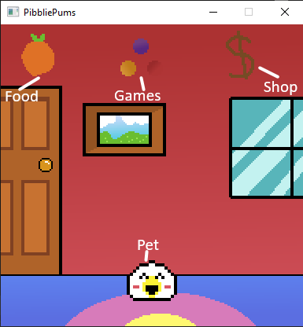

(Early Build of the game to give an idea of the look of the game)

## Project Scope

A summary of the scope of the game.

### Number of locations

* Pet’s room
* Shop
* Game area
* Food Inventory
* Status

### Number of levels

N/A

### Number of NPC’s

Shop keeper- Will manage stock and decide when to restock items.

Pet- Roams around the room, and change its mood based on its status. Also is your opponent during various minigames.

### Number of weapons

N/A

### Etc.

* 18 pets
  + 9 Adult forms
  + 6 Child forms
  + 3 Baby Forms

# Section II - Gameplay and Mechanics

## Gameplay

### Game Progression

### Mission/challenge Structure

N/A

### Puzzle Structure

N/A

### Objectives – What are the objectives of the game?

Raise your pet to adulthood

### Play Flow – How does the game flow for the game player

You start out with an egg which hatches over time. Out of the egg will hatch one of 3 random baby forms. This will then determine your pet’s line of evolution. It is now up to the player to determine the rest of the evolutions. The 3 stats that will determine a pet’s evolution are weight, average fullness, and average happiness.

Babies evolve quickly and become a child form after 2 hours. The child form then is given more time to develop. This will allow for more time to develop the three stats that define each evolution. After 18 more hours, your pet evolves into an adult form. The adult will stay with you for the rest of the 28 hours left. After that time, they will thank you by leaving a special egg and running off. This egg will hatch into a new pet. However, it will never hatch into the same evolution line that the last pet was.

## Mechanics

The major mechanics behind the pet are the three stats; fullness, happiness, and weight. Playing games with your pet will make them happier, reduce weight and fullness, and earn some money all if the player wins. The player can then use the money they earned to buy food and medicine. Feeding your pet can give them happiness, fullness, and weight. Certain food items have different amounts connected to them. Given your pet French fries will give them a large amount of weight and happiness, but low fullness. Giving your pet stir fry will give them high fullness, medium happiness, and low weight.

Each food item can have 0-3 in fullness or happiness. This will add to the pet’s happiness and fullness meter, which can be viewed in stats. meter will display how much a pet can handle in any of the stats. These meters will be different for each stage of the pet’s evolution. Baby pets only have a meter size of three. This makes the baby require little food and activity but be hungry and upset frequently. Children have 5 bars on their meter, and adults have 7.

However, you cannot just give a pet plenty of food to fulfill their needs. Any pet that gains a surplus or a deficit of 2 on their meter will cause them to become sick. This creates a balancing act of stats. If the player wants to get a rare pet, they will have to care for the pet without overflowing any stat.

### Physics

N/A

### Movement

#### General Movement

The pet moves on its own while in its room. The pet will randomly move left or right. Every few seconds, it will perform a movement check and move left, right, or remain where it is. If the pet is in the left or right side of the screen, it can only remain where it is, or return to the center.

#### Other Movement

Player moves between the areas using the HUD at the top of the screen. Selecting an icon will move the player to a new screen.

### Objects

#### Picking Up Objects

Player can receive items by buying them from the shop with player score.

#### Moving Objects

N/A

### Actions

#### Feeding

You can feed your pet by going to the pet inventory screen and selecting a food item to give them. This will raise their stat meters.

#### MiniGames

Minigames are the games only source of income.

Each age group has a different mini game.

**Baby: Rock Paper Scissors**

-A game of chance where you face against your pet in a game of Rock Paper Scissors

**Child: High Jump**

-A timing-based game where you must press the enter button when your pet’s jump meter is at its highest

**Adult: AstroBlaster**

-An action game where your pet pilots a space craft and must dodge/shoot incoming asteroids in 3 lanes.

Higher age groups have longer and more challenging minigames, so they will get more money that the previous one. Points are only award if the player reaches the requirement of a “win”.

### Economy

The game’s economy is based on the minigames. Playing minigames gives score, and score can be used in the shop to buy items.

## Screen Flow

### Screen Flow Chart

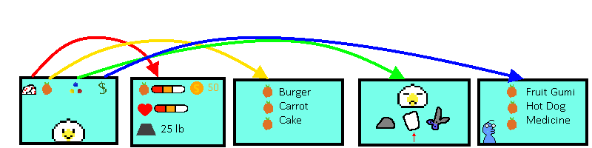

### Screen Descriptions

What is the purpose of each screen?

#### Room screen

Display the current pet and what it’s up to.

#### Stats screen

Displays each stat of the pet currently

#### Inventory screen

Displays the players current inventory. Items can be select from this screen to use the item on the pet.

#### Game screen

Screen used to play the mini games with the pet.

#### Shop Screen

Displays the current shop items. Items can be bought with money and added to your inventory

#### Stats screen

Displays each stat of the pet currently

#### Stats screen

Displays each stat of the pet currently

#### Stats screen

Displays each stat of the pet currently

## Game Options

TBD

## Replaying and Saving

The game will save your game state. However, your pet will continue to age while the game is closed.

## Cheats and Easter Eggs

N/A

# Section III – Story, Setting and Character

## Story and Narrative

Specific details like scripts and cut scenes may not be in this document but be in the Story Bible.

### Back story

Planet Pum has had a sudden infestation of Pibblies, a creature that multiplies and evolves quickly. The Pums see these creatures as vermin and have studied ways to prevent their rampant growth. In their research, the Pums notice that Pibblie’s growth rate is greatly stunted by large amount of oxygen. The Pums found a lone planet with large amount of oxygen, Earth. They quickly begin a project to warp the Pibblie eggs to this planet.

### Plot Elements

N/A

### Game Progression

N/A

### License Considerations

N/A

### Cut Scenes

Evolution animation where the pet slowly transforms into its new form

## Game World

### General look and feel of world

The game world will be cute and simple.

## Pets

### Pet #1: Eggy (Baby)

#### Personality

Innocent

#### Look

##### Physical characteristics



##### Animations

Each pet has a Walk, Upset, Sick, and Happy animation.



#### Relationship to other characters

Evolution line: TBD

### Pet #2: Bulbster (Child)

#### Personality

2cool

#### Look

##### Physical characteristics



##### Animations

 

#### Relationship to other characters

Evolution line: TBD

### Pet #3 Melon-chan (Adult)

#### Personality

Fruit?

#### Look

##### Physical characteristics

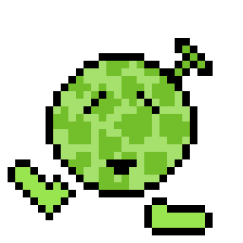

##### Animations

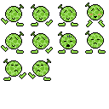

Relationship to other

# Section IV – Levels

N/A

# Section V - Interface

## Visual System

### HUD - What controls

The game has a 3-button control scheme. Left, right, and enter. The button inputs move between the HUD icons displayed above. Pressing enter will select that icon.

### Menus

The game’s icon select will always be active

An options menu may be added as well.

### Rendering System

TBD

### Camera

Side view always(Menu like)

### Lighting Models

N/A

## Control System

The game has a 3-button control scheme. Left, right, and enter. The button inputs move between the HUD icons displayed above. Pressing enter will select that icon.

## Audio

Simple beeps and boops

## Music

I will try and develop simple songs for the game myself.

## Sound Effects

Simple beeps and boops

## Help System

N/A

# Section VI - Artificial Intelligence

## Opponent AI

There may be various minigames which will require A/I. One minigame I am planning is a simple rock,paper scissors minigame which will require A/I

## Support AI

### Player and Collision Detection

N/A

### Pathfinding

The pet will be able to wander around their room. They will have to know how to path without leaving the screen.

# Section VII – Technical

## Target Hardware and operating system

Windows 10. Simple 2d rendering

## Supported game controllers and peripherals

N/A

# Section VIII – Game Art

Only show concept art here (rough sketches)

## Concept Art

## Style Guides

Reference guide:

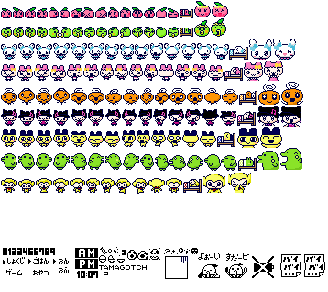

## Characters

  

## Environments

TBD

## Equipment

TBD

## Cut scenes

N/A

## Miscellaneous

N/A